CELL DIVISION
The most important biological process of both sexually and asexually reproducing organisms by which the cell produces its exact copy or replica or duplicate is cell division. Cell division is a part of cell cycle. There are two type of Cell division -Mitosis and meiosis.
Mitotic cell division
The mitosis (Gr., mitos-thread) occur in the somatic cells and it is meant for the multiplication of cell number. Fundamentally it is related with the growth of an individual. This type of cell division is of universal occurance and is found in all living beings. Mitotic cell division is called equatorial cell division, as it results in two daughter cells having the same number of chromosomes as the parent cell. Mitotic cell division is also called somatic somatic cell division.
PROCESS OF MIOTIC CELL DIVISION
Mitotic cell division involves two main events-
- Karyokinesis- the process of cell division of nucleus
- Cytokinesis- the process of cell division of cytoplasm
I) Karyokinesis-Te process of cell division involves series of continuous events but for convenience it is divided into several stages. The karyokinesis involves following phases-
- Prophase- The appearance of thin thread like condensing chromosomes marks the first phase of mitosis, called prophase (Gr., Pro-before, phases-appearance). The cell at this stage become spherical in structure. Each chromosome is composed as two longitudinally coiled filaments, the chromatids or chromonemata. As prophase progress, the chromatids become shorter and thciker and two sister chromatids are held together by centromere or primary constriction which is organized by trilaminar kinetochore protein. Further in the early prophase the chromosomes are evenly distributed in the nucleoplasm but they donot come in contact with each other. The centrosome of the prophase divides into two centrioles and they start migrating towards the opposite poles. Each centrioles produces ray like cytoplasmic process called astral rays (composed of microtubule) which form spindle fibres extending between the two centrioles. This spindle is called as mitotic apparatus. The nuclear membrane and nucleolus start disintegrating and by the end prophase they completely disappear.

- Metaphase- During metaphase (Gr., meta-after) the chromosomes are shortest and thickest. They start moving towards the equatorial plane of cell and at last they lie in the equator. Their centromeres occupy the plane of equator of the mitotic apparatus (a region known as equatorial or metaphase plate). At this stage the sister chromatids are still together by centromere and kinetochores of the two sister chromatids face opposite poles. At metaphase the plus end of a microtubule at the kinetochore and minus at the centrosome.
- Anaphase- It is the shortest stage of mitotic cell division. It is initiated by the contraction of the spindle fibres. As a result of great pull by the fibres the the centromere divides to separate the two chromatids. The sister chromatids are now called daughter chromosomes. The spindle fibre still contract, thereby dragging the daughter chromosomes ton the opposite poles with them. At this stage the chromosomes appears as “V” or “L” shaped structure. At the end of this stage the chromosomes are separated into two equal numbers and hence they have the same genetic constitution. Thus the distribution of chromosome in anaphase both quantitatively and qualitatively equal.
- Telophase- This is the last stage of karyokinesis. The chromosomes are reach at the opposite poles of the cell now elongate and coils of DNA and protein start uncoiling. As a result the chromosome retain original shape. The nucleolus and nuclear membrane reappear at the opposite pole of the cell at telophase. By the completion of telophase two daughter nuclei are completely reorganised at the opposite poles of the cell.
- Cytokinesis- The karyokinesis is followed by the division of cytoplasm which is also called cytokinesis. Cytokinesis is accomplished by the formation of a cell plate. Its formation depends upom the presence of certain elements of the reticulum which gather in the equatorial plane of the cell, between the daughter nuclei. This gradually deepens and converge on all the sides so that the parent cell equally divides into two daughter cell each containing a set of chromosomes.

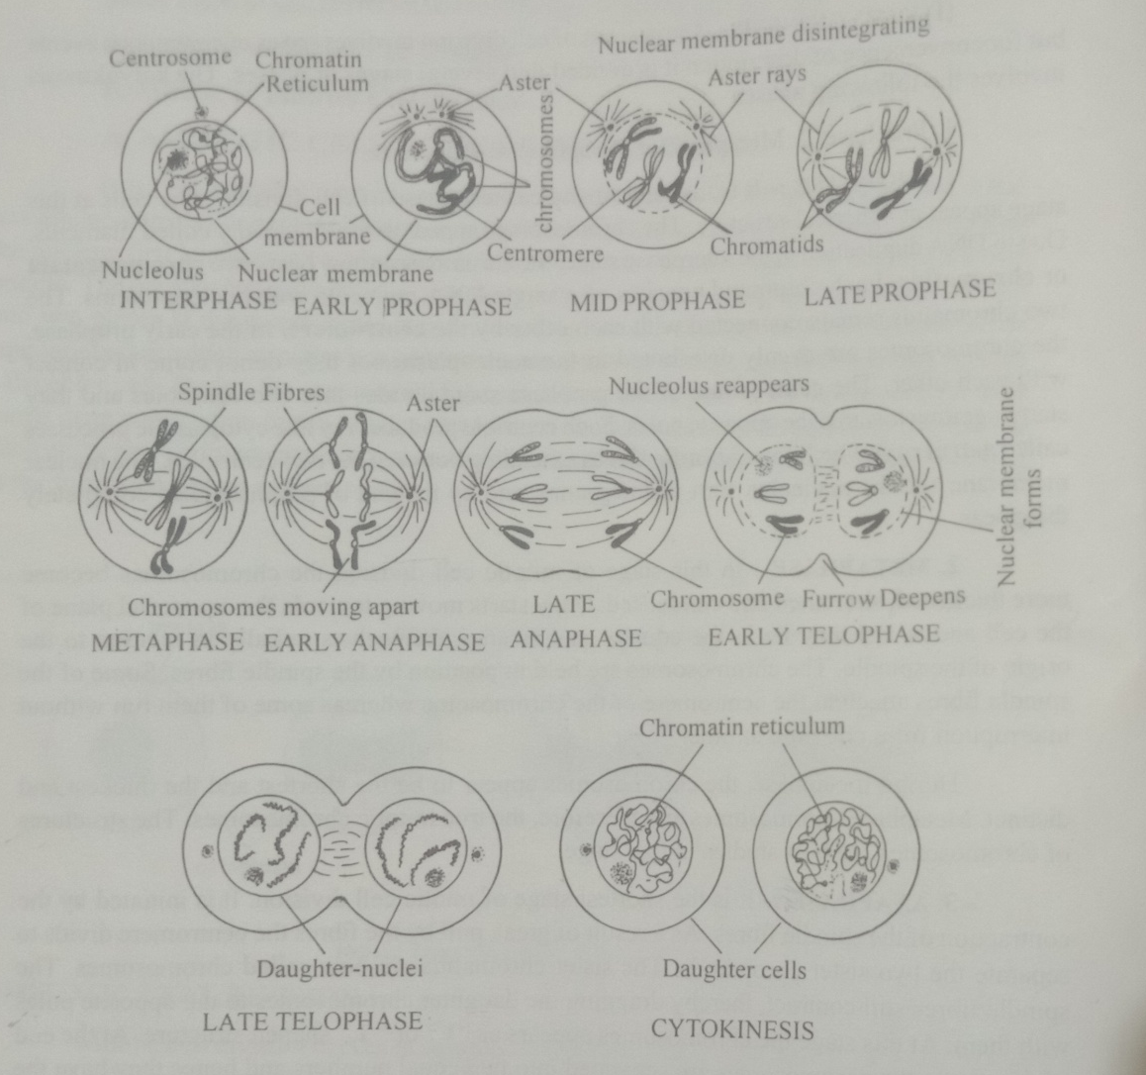
Fig Mitotic cell division

Significance of Mitotic cell division
Mitosis has following significance in the biological world
- It helps the cell in maintaining cell shape.
- It helps in the maintainance of an equilibrium in the amount of DNA and RNA in the cell
- It provides opportunity for somatic growth and development to organs and body of oraganisms. It gives rise to two daughter cells which are exactly similar with the parent cells.
- Through mitotic cell division the old decaying and worn out cells and tissues are replaced by new cells.
- The chromosome number in each daughter cell remains are same as parent cell.
- It helps in asexual reproduction.

Meiotic cell division
Meiotic cell division occurs in germ cells. It results in the formation of gametes. In this type of cell division the diploid (2n) number of chromosome of parent cell is reduced to haploid (n) in daughter cell. The opposite gametes during fertilization contribute haploid (n) set of chromosome to the zygote that contains diploid (2n) number of chromosome. Thus in sexually reproducing organisms this cell division helps in maintaining the constant number of chromosomes generation after generation in a particular species.
Process of Meiotic cell division
Meiotic cell division involves two cell divisions. The first cell division is the reduction cell division because it results in the formation of two haploid (n) daughter cells. The second cell division is the equational cell division i.e. each haploid daughter cell of the first meiotic cell division undergoes mitotic cell division to produce similar haploid cells. Thus at the end of the meiotic cell division four haploid cells are produced.
- First meiotic or Heterotypic cell division
Meiotic cell division involves two main events- Karyokinesis and Cytokinesis
- Karyokinesis of meiotic cell division consists of four phases prophase I, metaphase I, anaphase I and telophase I.
- Prophase I-It is the longest phase of first meiotic cell division. It has been distinguished into five sub stages. These are-Leptotene, Zygotene, Pachytene, Diplotene and Diakinesis.
Leptotene or leptonema stage- In the leptotene stage, the chromatin reticulum of the interphases cell become fragmented and condensed to form distinct thread like structures called chromosomes. During this stage the amount of DNA is doubled. The chromosomes of leptotene stage appear beaded. The beads are due to the condensation of chromatin material and coiling of chromonema. The beads like structure are called chromomeres. In this stage the centriole starts dividing into two and each of them starts moving to opposite sides around the nuclear membrane and the astral rays becomes clearly distinguished.
Zygotene or zygonema stage - The most significant event of zygotene stage is the pairing of homologous chromosomes. They get arranged close to each other to form bivalent (paired homologous chromosome or diad). This pairing of homologous chromosome is called as synapsis. The pairing of homologous chromosome is very accurate which involves point or gene to gene pairing over the whole length of the chromosome. The size of the nucleolus increases and the centrioles still move towards the opposite poles. Between the two centrioles astral rays form spindle fibres.
Pachytene or pachynema stage- It is the most significant stage of prophase I of meiotic cell division. Each chromosome of a pair bivalent splits into two longitudinal chromatids but they remain unspli tted at a point called centromere. As a result of longitudinal splitting of each chromosome of a pair of bivalent, four chromatids are produced from one pair of homologous chromosome. This four stranded bivalent is known as tetrad or tetravalent. The nonsister chromatids of a pair of homologous chromosome start coiling and the point where they come in contact are called chiasma (sing=Chiasmata). AT chiasma the non sister chromatids break and exchange of chromosomal segments takes between them. This is known as crossing over.
Diplotene or diplonema stage- In this stage the chromosomes become more thickened, shortened and condensed. After the genetic material is exchanged the bivalents repel each other and begin to separate. The bivalent separate from each other all throughout the length except at the terminal chiasma. The nuclear membrane and the nucleolus starts disappearing.
Diakinesis- This is the final stage of prophase I of meiotic cell division. The chromosomes further shorten and thicken and the homologous chromosomes move further away from each other. The nuclear membrane and the nucleolus completely disappear from the cell in this stage. The centrioles get settled in the opposite poles of the cell.
- Metaphase I- The chromosome are arranged at the equatorial plane and become greatly coiled. The spindle fibres established connection between two centriooles. Some of the spindle fibres attach to each chromosome of a bivalent. The cetnoromere of each chromosome is directed towards the opposite poles. A great repulsive force is created between homologous chromosomes and they are ready to separate.
- Anaphase I- As a result of contraction of spindle fibres the chromosomes are start moving towards the opposite poles of the cells. The two chromatids of a chromosome donot separate, therefore, the chromosome number is reduced to half towards both poles. Each pole has now a haploid (n) number of chromosome.
- Telophase I- The haploid set of chromosomes arranged in opposite poles of the cell becomes uncoiled, long and thin thread like structure. Around the haploid group of chromosomes at the opposite poles the nuclear membrane reappears. As a result, two daughter nuclei are produced, one at each pole having half the number of chromosome
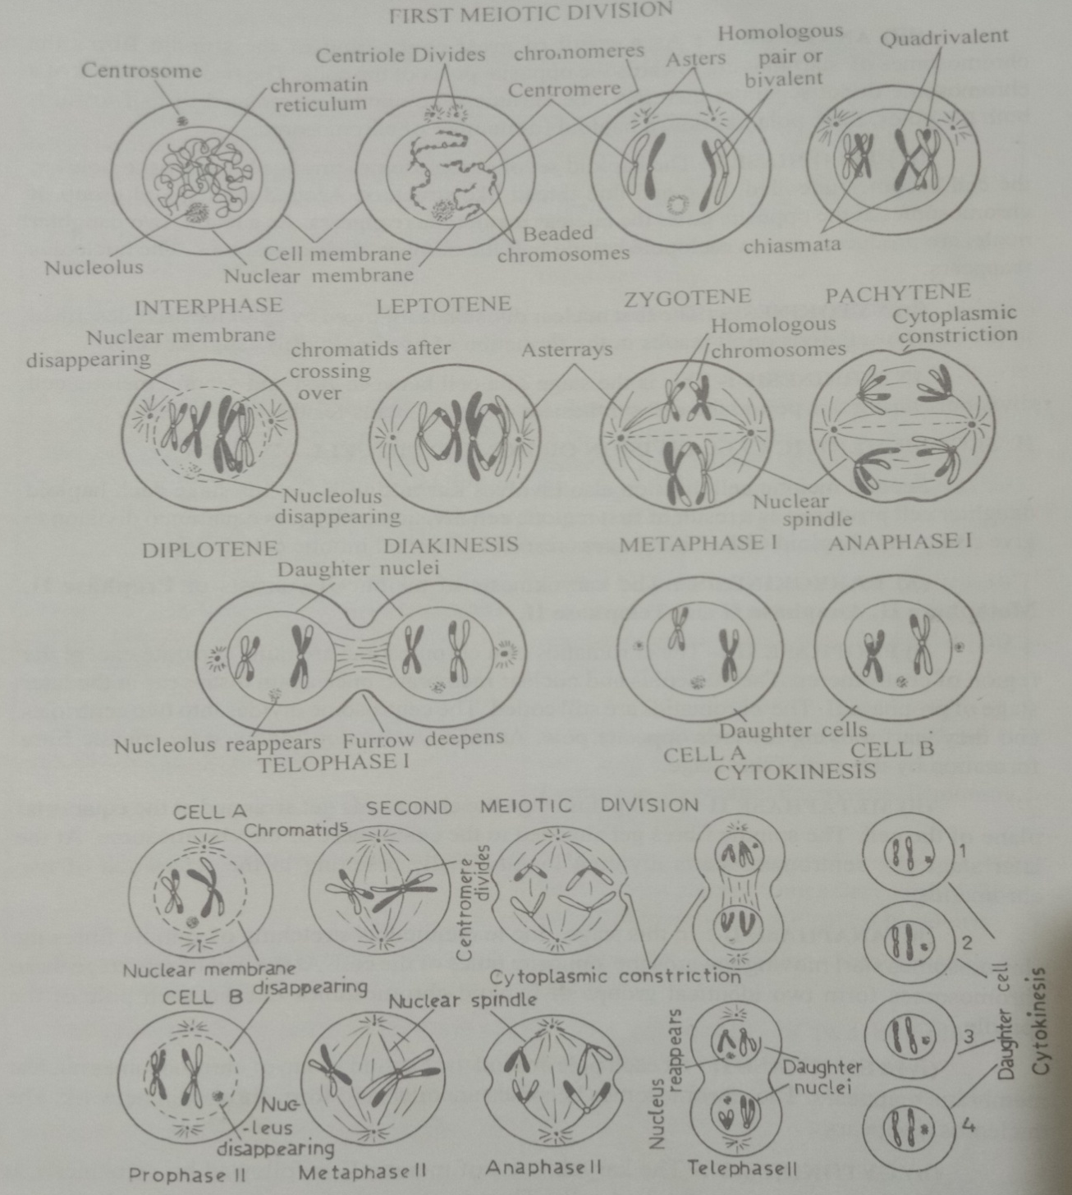
- Cytokinesis- the first nuclear division is followed by cytokinesis. It results in the formation of two haploid(n) daughter cells.

Fig: Meiotic cell division

- Second meiotic or Homotypic cell division
Second meiotic division also involves karyokinesis. In this stage each haploid daughter cell produced as a result of the first meiotic cell division undergoes equatorial division to give rise two haploid cells.

- Karyokinesis- The karyokinesis of meiotic II consists of Prophase II, Metaphase II, Anaphase II and Telophase II.

- Prophase II- The chromatids of a chromosome are quite separate except the region of centromeres. The nucleolus and nuclear membrane once again disappear in the later stage of prophase II. The chromatids are still coiled. The centrosome divides into two centrioles and they start moving towards opposite poles. Astral rays develop followed by spindle fibre formayion by the end of this stage.
- MetaphaseII- During this stage the chromatids get arranged at the equatorial plane of the cell. The spindle fibres get attached to the centromere of the chromosome. At the later stage the centromere starts dividing longitudinally resulting in the separation of two chromatids.
- Anaphase II- In this stage, due to continuous stretching of spindle fibre the chromosomes start moving towards the opposite poles of the cell. At the end of this stage chromosomes form two identical groups of haploid chromosomes one on each pole of the spindle.
- Telophase II- At each pole around the haploid group of chromosomes nuclear membrane reappears. The chromosomes becomes uncoiled and form chromatin network. The nucleolus reappears.
- Cytokinesis- The karyokinesis of meiosis II is followed by cytokinesis. It results in the formation of two haploid cells. Thus, at the end of second meiotic cell division four haploid cells are produced.
Significance of Meiosis
- Through meiosis, constant number of chromosome in a species is restored through genetic fusion in sexually reproducing organisms.
- Since any of the two members of each bivalent in metaphase can move to the two opposite poles, a variety of combinations of paternal and maternal characters are found in different gametes and consequently in next combination.
- Due to crossing over, the genetic material between two corresponding segments of non-sister chromatids of a pair of homologous chromosome genetic variation takes place in the gametes which improves genetic combination.
- Genetic combination and recombination help in bringing about variation which are often essential for survival of population.
Differences between Mitosis and Meiosis
Sl. No. | Mitosis | Meiosis
1 | Occurs in somatic or body cells | Occurs reproductive cells
2 | Found in both sexually and asexually reproducing organisms | It is characterstic of sexually reproducing organisms only
3 | It is involves only one nuclear division which involved in the duplication of chromosomes. | Meiosis involves two nuclear divisions but chromosomes are duplicated only for once
4 | The main function is to increase the number of somatic cells. This helps in somatic growth of the body. | Main function is to produce gametes. Two haploid (n) gametes fuse to form diploid (2n) zygote. Through this process, the sexually reproducing organisms maintain chromosome number constant
5 | It is called equational cell division because, the daughter cells are similar to parent cells in chromosome number. | The daughter cells do not resemble to parent cell in chromosome number. The diploid (2n) number of chromosome is reduced to half (n) in daughter cells.
6 | Prophase stage is short and is not divided into sub-stages. | Prophase is very long consisting of sub-stages viz. Leptotene, Zygotene, Pachytene, Diplotene and Diakinesis.
7 | Homologous chromosomes do not pair | During zygotene stage of prophase I, the homologous chromosome starts pairing. The paired chromosomes are called bivalents.
8 | Synapsis, crossing over, chaisma formation donot occur. | These are significant characteristics of meiosis.
9 | Chromatids are found in the form of diad | Chromatids of two homologous chromosomes occur as tetrad.
10 | At the end two cells are produced | At the end four cells are produced

