UNIT: 2
CHANGING STRUCTURE OF INDIAN AGRICULTURE
It is known that the decline in the share of agricultural workers in total workers has been
slower than the decline in the share of agriculture in the GDP. There is a need for structural
change in both output and employment of agriculture.
Agricultural GDP +: It may be noted that agricultural GDP refers to agriculture and allied
activities. But, if we extend this to throughout the value chains which includes food and agro
processing, the share of agriculture GDP will be much higher and has significant linkages
with other sectors. Therefore, we can have agriculture GDP+ if we extend the activities and
its share in overall GDP would be much higher.
Growth in Agricultural GDP: In the decade of 1960s, agricultural growth rate was around 1%
per annum (Table 1). In other periods, the growth rates range from 2.2% to 2.7% per annum.
In the post-reform period, growth rate of services was more than 8% per annum. Industry also
recorded 7 to 8% during 2004-05 to 2017-18. The highest growth rate of GDP from
agriculture was 3.7% per annum during 2004-05 to 2013-14. The growth rate in agriculture
in the period 2009-10 to 2013-14 was 4.3% per annum. This is one of the highest growth
rates recoded in independent India.
The growth rate in agricultural GDP was 2.5% per annum in the last four years of NDA
period 2014-15 to 2017-18. To be fair to the government, the first two years had growth rates
of -0.2% and 0.7% due to drought. The growth rate in 2018-19 is expected to be around
3.2%. If we add this, the rate of growth in agricultural GDP would be 2.7% per annum for the
five year period 2014-15 to 2018-19.
Volatility in agricultural production: One of the problems in agriculture is volatility in GDP
and production. However, the coefficient of variation has declined from 2.76% during 1961-
1988, to 1.87% during 1988-2004 and to 0.75% during 2004-2014 (Table 2). It shows that
volatility in agricultural growth has been declining and it was low in the last decade.
Variability in pulses was very high at 20% and 5% for cereals during 1990-2004. But it
declined drastically in the decade 2005-2014. In other words, resilience to rainfall has been
rising for Indian agriculture.
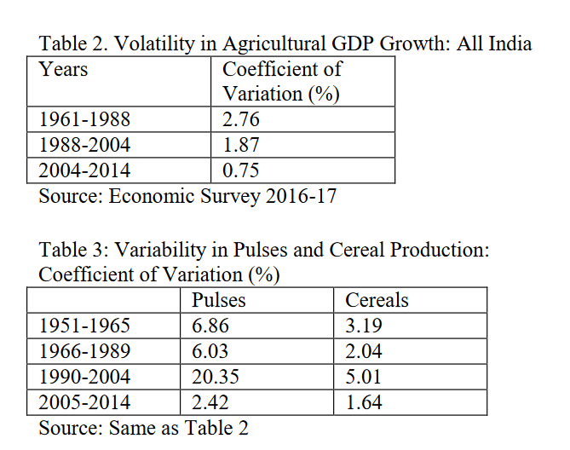
Decline in rise of agricultural prices: Prices play an important role in raising incomes of farmers. In the last one and half years, price rise for agriculture has declined significantly and affected the incomes of the farmers adversely. Table 4 provides implicit price deflators for agriculture GVA and total GVA. In 2015-16 and 2016-17, inflation for agricultural GVA was higher than that of total GVA.
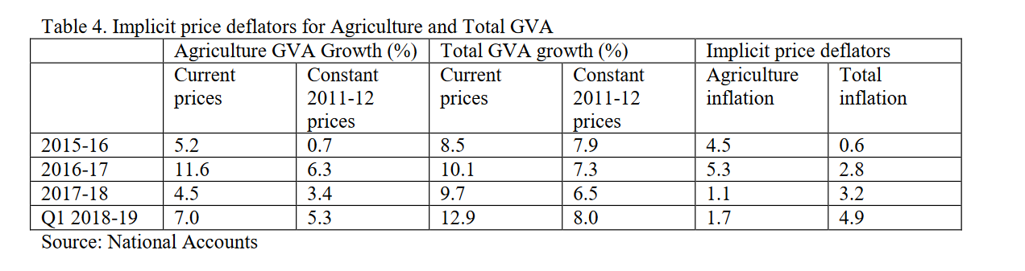
Changing face of agriculture and rural India: Structural change and transformation
There has been significant transformation in agriculture and rural areas. Structural change
happened at three levels: (1) diversification within agriculture sector; (2) diversification from
agriculture to allied activities like livestock and fisheries; and (3) structural change from
agriculture & allied to rural non-farm sector.
In terms of area, the share of nutri-cereals declined while the shares of oilseeds and fruits and
vegetables increased (Table 6). In the case of value of output in agriculture and allied
activities, the shares of nutri-cereals, pulses declined while the shares of fruits and vegetables,
condiments &spices, livestock and fisheries rose over time (Table 7).
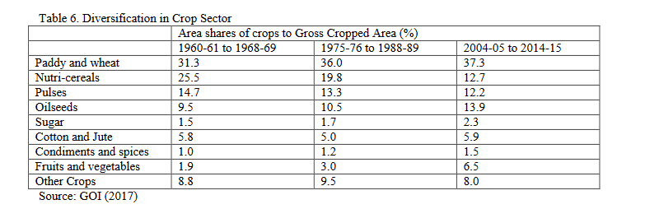
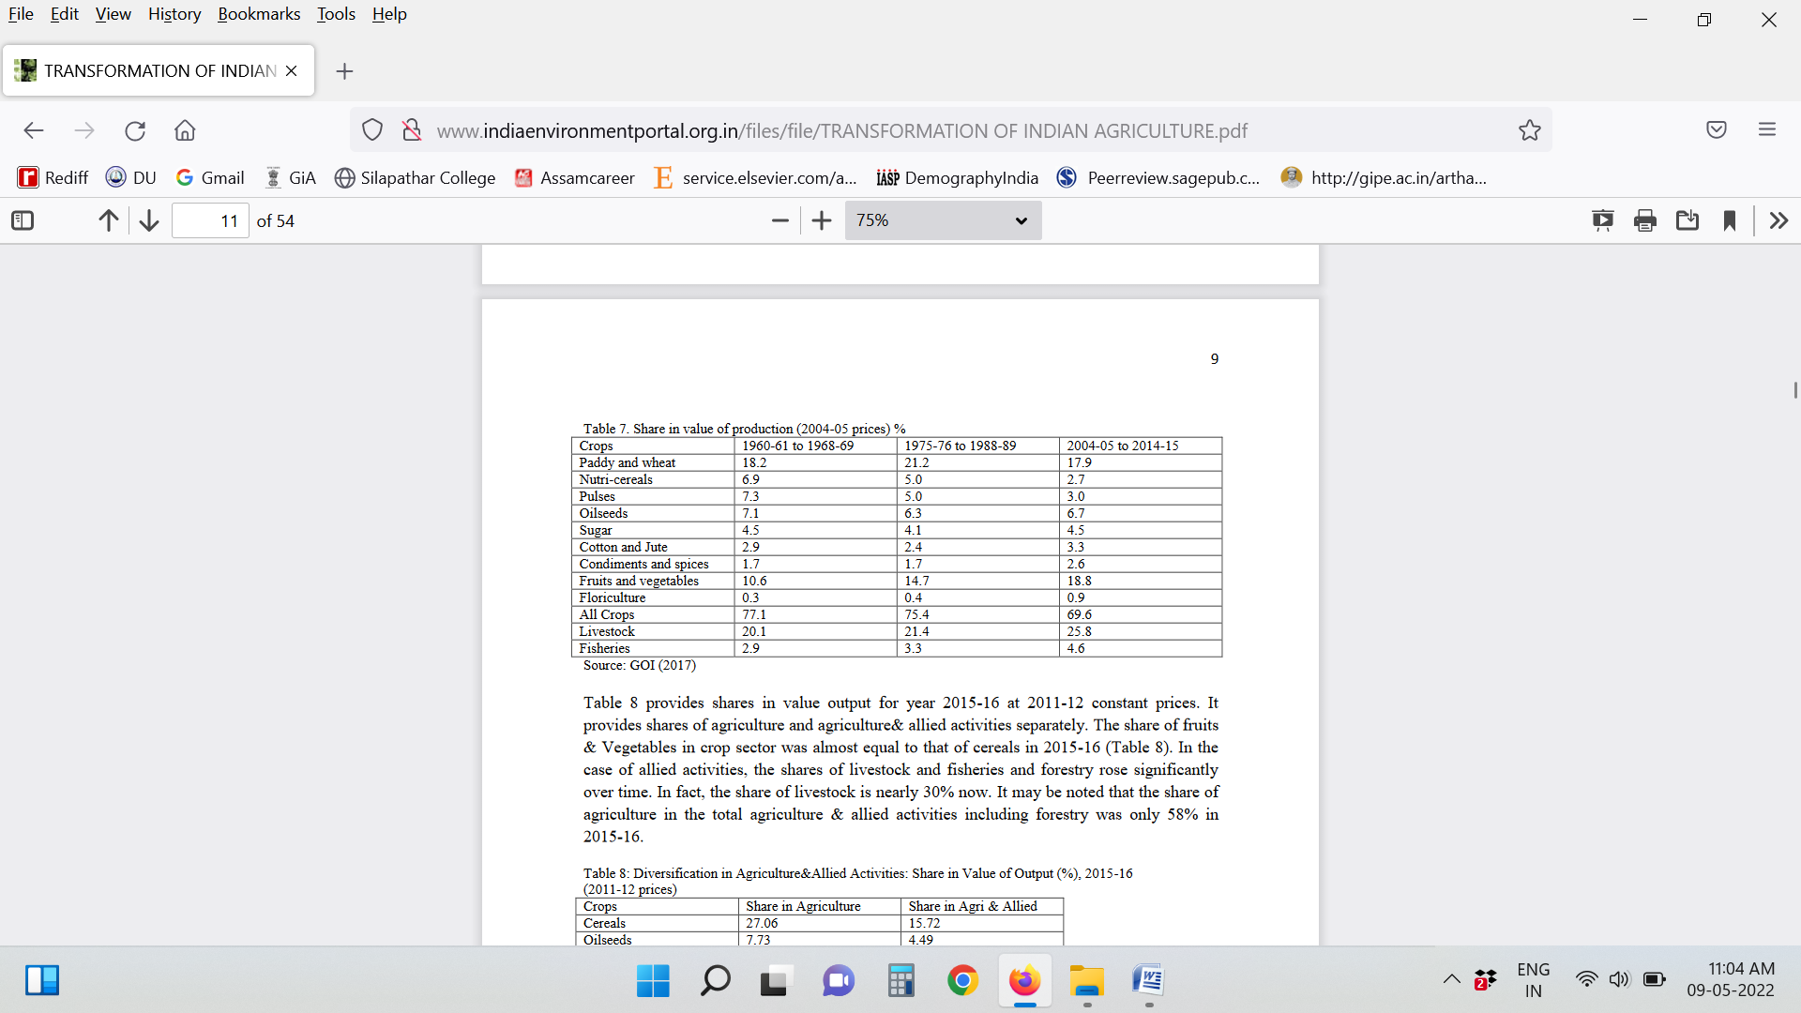
Important Points to Remember:
- The share of fruits & Vegetables in crop sector was almost equal to that of cereals in 2015-16.
- In the case of allied activities, the shares of livestock and fisheries and forestry rose significantly over time. In fact, the share of livestock is nearly 30% now. It may be noted that the share of agriculture in the total agriculture & allied activities including forestry was only 58% in 2015-16.
- There has been diversification of Indian diets away from food grains to high value products like milk, meat products, vegetables and fruits.
- The increasing middle-class due to rapid urbanization, increasing per-capita income, increased participation of women in urban jobs and impact of globalization has been largely responsible for the diet diversification in India.
- High value products have caught the fancy of the expanding middle class and the result is visible in the growing demand for hi-value processed products. Demand for non-food grain items has been increasing. The expenditure elasticity for non-cereal food items is still quite high. Per capita consumption of fruits and vegetables showed the highest growth followed by edible oils.
- Diversification to high value crops and allied activities is one of the important sources for raising agricultural growth.
- Agro processing and retail trade: Food and agro processing sector has huge potential for India in agricultural transformation. The country processes only 10 per cent of fruits and vegetables while many other countries process 40 to 70 per cent. Several changes have been occurring in value chains in the segments of food processing, cold chains, wholesalers, and logistics and they impact the linkages. Similarly promotion of retail trade and foreign direct investment in this sector will also help promoting linkages. The major change in food value chain is emergence of supermarkets.

ANC

